Hornsey Lodge No. 890
The Metropolitan Escorting Officers’ Lodge

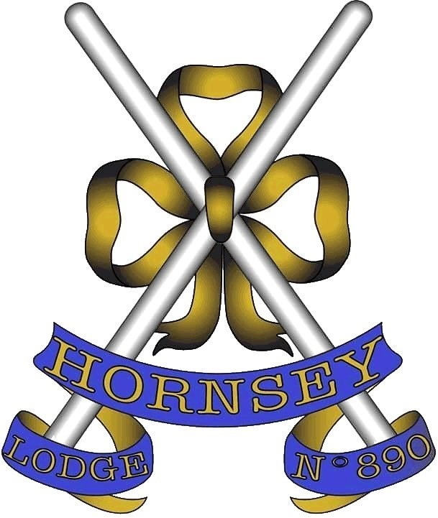
Consecrated on the 18th of December 1861

A Hall Stone Lodge

On The Occasion of the First Meeting as the new
Metropolitan Escorting Officers’ Lodge, on Wednesday 22nd of March 2017,
The Great Hall, St Bartholomew’s Hospital, West Smithfield, London,
EC1A 7BE

The Steering Committee
The following Brethren have had the honour of sitting on the steering committee of the Metropolitan Escorting Officers’ Lodge, and were elected as its first new members.
W.Bro. Howard Becker, SLGR W.Bro. Anthony Codd, LGR
W.Bro. Graham Cottington, LGR W.Bro. John Gent, SLGR
W.Bro. Andrew Green, LGR W.Bro. David Jacobs, SLGR W.Bro. Ivor Macklin, LGR W.Bro. Michael Palmer, LGR W.Bro. Carl Pendlebury, LGR

When they started, the nine members of Steering Committee had the idea of maintaining and developing the friendships they had made during their year in office as Escorting Officers. However, this soon expanded from a purely social aim, to include starting a Lodge that would allow that to happen. Despite a number of setbacks along the way, the team have now established a unit under the auspices of Metropolitan Grand Lodge, which it is hoped will provide a focus for past (and indeed future) Escorting Officers, long into the future.
It became evident at an early stage, that authorisation for the consecration of a new Lodge would be unlikely, but taking over an existing Lodge in the process of handing in its Warrant, and thereby ensuring the ongoing success of a Lodge otherwise in danger of being lost for good, would be much more likely to be approved. Having provided MetGL with the required assurances that the ‘new’ Lodge would not adversely affect other Metropolitan Lodges, would be financially viable, and that the team had the expertise to see the process through, the stage was set, but the work to get us to where we are today was only just beginning.
It is hoped that Hornsey Lodge Members will appreciate the time and effort of the Committee, and at the Festive Board will be proud to take wine with “The Steering Committee”, who can be identified by their distinctive blue firing glasses.

Welcome from the Master Elect
Acting as an Escorting Officer in Metropolitan Grand Lodge is one of the highpoints for many Masons who are privileged to take that Office. Unfortunately, it seems to finish all too soon! In view of this, in 2015, a small number of them, feeling that the end of their year was an anti-climax, decided to form themselves into a Steering Committee and start a Lodge specifically to address the issue. After a lot of hard work, our planning has come to fruition and the Lodge is now in exist- ence.
The objectives of the group are partly social: to continue, enjoy and develop the friendships and acquaintanceships made during the year in office; and partly practical: to provide support and encouragement to new active EOs. It also benefits Metropolitan Grand Lodge in filling a gap in the Metropolitan structure by creating a specialist Escorting Officers' Lodge without adversely affecting other specialist Lodges. In addition, it can provide resources for individual mentoring of new EOs, and be a focal point for recruiting qualified candidates to the VO’s scheme. It was for these reasons that Metropolitan Grand Lodge gave their approval for such a Lodge to be formed, for which we are very grateful.
We were very fortunate in being able to find a Lodge, Hornsey No. 890, with such a long and distinguished history and which was willing to transfer stewardship of the Lodge to us. We were also fortunate that two of Hornsey’s senior members agreed to become Honorary Members of the rejuvenated Lodge, thereby providing continuity. Hornsey will now be a Lodge of Past Masters, but with a difference to those already in existence. Meeting twice a year, in the superb venue of the Great Hall at The Royal Hospital of St Bartholomew, known simply as “Barts”, this outstanding location will allow us to enjoy fine dining at the conclusion of our Masonic business.
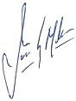
We hope you enjoy your evening with us and thank you for being able to partici- pate in the revival and inauguration of new members into Hornsey Lodge No 890.

Ivor Macklin
Master Elect & Chairman of the Steering Committee

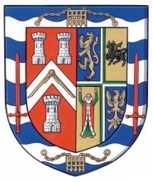

METROPOLITAN GRAND LODGE
of
LONDON

To The Worshipful Master, Officers and Brethren of Hornsey Lodge No. 890

Greetings.
I send you my heartiest congratulations on your inauguration as the Metropolitan Escorting Officers’ Lodge.
I am particularly pleased that an old, well established Lodge, such as Hornsey, which was consecrated over 150 years ago, should be afforded a new lease of life in this 21st Century. Its rejuvenation is testament to the will, forethought, determination and not least the industry of the new Members and particularly that of the Steering Committee, in bringing this fine project to fruition.
I see the Lodge going from strength to strength in the coming years and becoming a pivotal and prominent member of Metropolitan Grand Lodge. It will serve as an example to others not only in enabling and ailing Lodge to continue but its members, relatively young as they are, will be seen to maintain the commitment, resolve and high standards so ably demonstrated during their year as Metropolitan Escorting Officers.
I send my very best wished to you all for the continued existence and well- being of the Lodge and the Good Works you do.
Yours sincerely and fraternally,

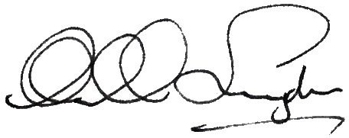
Sir Michael Snyder Metropolitan Grand Master
Original letter in Lodge records

A Brief Lodge History

Hornsey Lodge No. 890
Hornsey Lodge was consecrated in December 1861, with all the Founders, as well as all the Initiates for many years, being described as either ‘Licensed Victuallers’ or ‘Gentlemen’. It was originally allotted number 1192, but was given its current number of 890 when Grand Lodge closed the gaps which had resulted from the closure of a number of lodges and others in the Dominions being transferred to new Grand Lodges. For the first four years of its existence the lodge met in the now defunct Albion Tavern in Stoke Newington, perhaps unsurprisingly being as all the Founders were from that area. It then had spells in Anderton’s Hotel in Fleet Street, Freemasons’ Hall, and the Hotel Cecil, where it remained for 15 years, before moving to The Cafe Monico, and when that closed down in 1941, back to Freemasons’ Hall, where it remained for many years. Lodge membership peaked at 59 in 1878, but was more often between 40 and 50, and with visitors the lodge regularly dined between 120 and 150, figures that the lodge is hoping to return to in the near future. In the early years they would also have had around 8 Initiates a year, although this fell to 2 or 3 between WW2 and the 1970s, with meetings of around 40 brethren. For many years the ritual of the lodge was Emulation, but in 1972 it moved to Universal workings, with every new ritual book being donated by W.Bro. Norman French, who wrote a personal message for the recipient in each.
By the 1980s numbers were somewhat lower however, and the lodge was finding the cost of meeting in Great Queen Street and dining at the Connaught Rooms, ever more difficult to manage. As a result the lodge moved to Clerkenwell, but be- ing dissatisfied with what they found, soon returned to Freemasons’ Hall, although finding elsewhere to dine, trying various local bars, restaurants, clubs and hotels. Nevertheless, numbers continued to decline, such that there were many occasions when it was difficult even to fill the offices, and so in the mid-1990s the lodge took the decision to leave the city centre and return to north London, albeit in Southgate rather than Stoke Newington, where it remained until another period of declining membership, resulted in Hornsey Lodge amalgamating with Tudor Lodge in 2007, and then finally preparing to hand in its warrant. Thanks to the formation of a Metropolitan Escorting Officers Lodge however, it managed to escape this fate, and it is now hoped that in its new guise the future of the lodge will be secure.

Prized possessions:
Hall Stone Jewel: Received on behalf of the Lodge by W.Bro. Hollander on the 6th of March 1929, following an amount subscribed of
£367.19s.6d.
Firing glasses: Donated by a Manchester lodge, and now in the museum at Freemasons Hall. They are the inspiration for the firing glasses to be used by the Escorting Officers’ Lodge.
Banner: Presented by W.Bro. Michael Peak, and bearing an image of Hornsey Church Tower, the only remaining part of Hornsey’s oldest building.
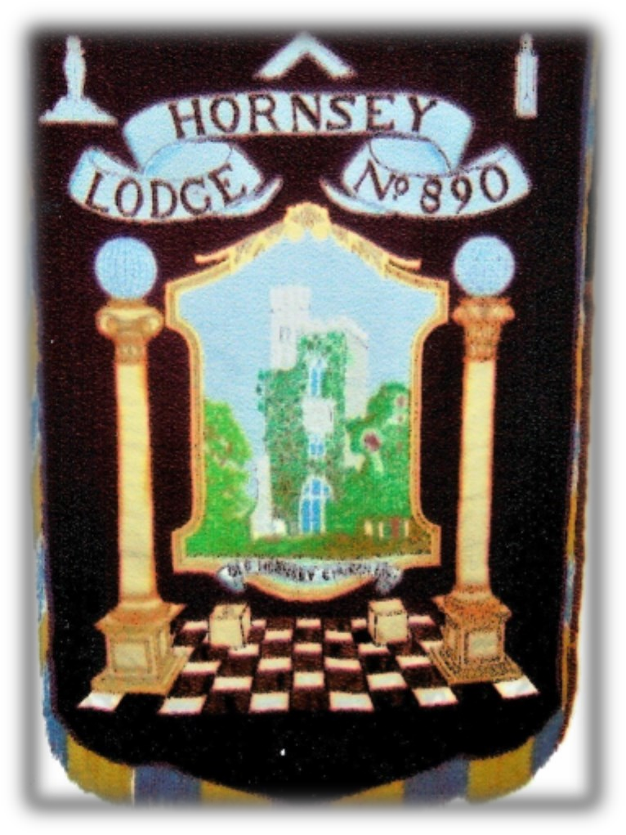
Hornsey Lodge banner

Charity box: The lodge owns a silver Charity Box, each corner of which is inscribed with the words ‘Faith, Hope and Charity’.
Tudor Lodge No. 6681
Like many lodges, the post war period saw an influx of members at Ronaldshay Lodge No. 3376, such that it could take 20 years to reach the chair of their mother lodge, and as a result, at the second meeting of the reformed LOI in 1947, the Preceptor suggested the formation of a new lodge. So was born the idea for Tudor Lodge No. 6681, which was issued a warrant in May 1948, and duly consecrated in July of the same year, with the first regular meeting in September. Why the name Tudor Lodge was chosen is uncertain, but it is clear that most of the early membership came from the Finchley area, and with the name Finchley having been taken by an earlier daughter lodge of Ronaldshay, it is thought they may have taken the name from the then Tudor telephone exchange, which covered Muswell Hill.
Like Hornsey Lodge, Tudor moved around a bit, starting in a cramped room upstairs at the Horse Shoe Hotel (Tottenham Court Road), before moving on to Lyons Oxford Corner House, Whitehall Court, the Commonwealth Society and the National Liberal Club, before settling on Southgate Masonic Centre in 1976. In the early years most meetings involved two double ceremonies (i.e. four candidates in all), in order to keep pace with the number of men wishing to join; however, the move north from the city centre meant that the lodge could no longer recruit from all sides of the capital, and consequently membership began to fall. As a result, in December 2007 the lodge was erased, having amalgamated with another Southgate based lodge in Hornsey Lodge No. 890.

Meeting Venue

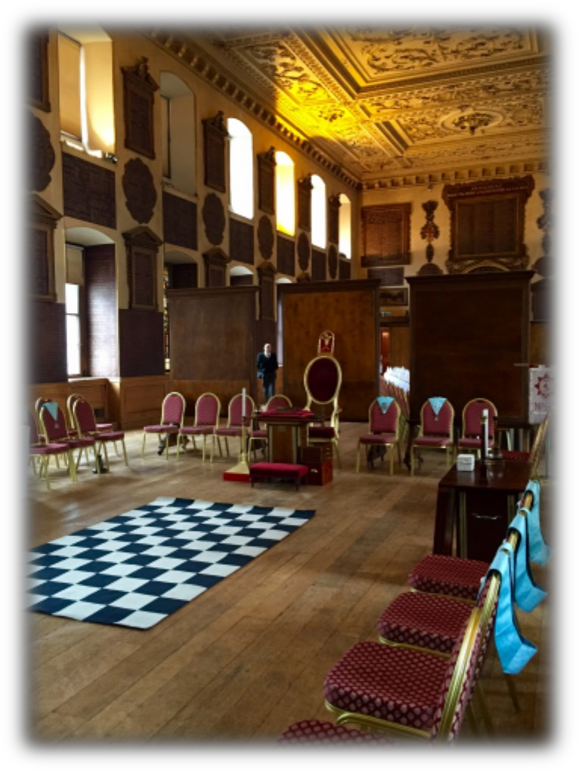
The Great Hall at
St Bartholomew's Hospital
St Bartholomew's Hospital was founded in 1123, by Rahere (a courtier of Henry I), making it the country’s oldest hospital still serving in that role. Rahere, apparently made a vow when he fell sick while on a pilgrimage to Rome, and a vision of St Bartholomew, inspired him to found a priory and a hospital for the sick and poor. For a while the hospital was run by the brethren and sisters of the Priory, but over the next 3oo years the two bodies almost totally separated, so that when the priory fell

victim to the dissolution of the monasteries in the
Great Hall, St Bart's Hospital

reign of Henry the VIII, the hospital endured, although it’s major source of income, and therefore security, had gone. Following a petition from the citizens of the city however, in 1546 Henry granted the hospital to the City of London, together with letters patent a year later endowing it with properties and income to secure it’s future. The hospital was again threatened in 1666 however, by the Great Fire of London, which left the hospital itself undamaged, but the devastation of the city resulted in the loss of many of the hospital’s properties, and therefore the income they generated, necessitating the closure of several wards.
Between 1729 and 1770 the hospital was rebuilt to designs by James Gibbs, one of the most influential British architects of the 18th century, and many of the buildings from that time still exist, including three of the original four blocks that surrounded the square and the earlier (1702) King Henry VIII Gate. It is in the North Wing that the Great (or Governors) Hall is found, a magnificent room that as well as originally housing the administrative roles of the hospital, was used to entertain wealthy charitable benefactors, making it an apt place for Freemasons to meet. The Hall is approached via a grand staircase decorated with two large paintings by William Hogarth (referred to simply as the Hogarth murals), depicting the biblical stories of ‘The Good Samaritan’ and ‘Christ at the Pool of Bethesda’, which reflect the ethos of the hospital. Interestingly, these paintings are still used as teaching aids, since although they portray biblical scenes, many of the characters are thought to represent patients, with (to the well informed) recognisable ailments.

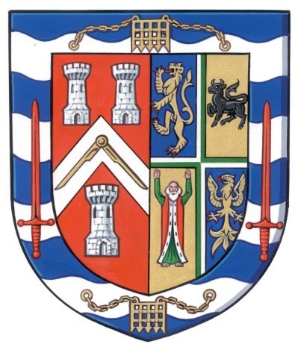

Metropolitan Installing Team
Worshipful Master V.W.Bro. Cdr. Ian Wellesley-Harding, RN,
PGSwdB, AMetGM
Senior Warden W.Bro. Colin Barrow, CBE, PSGD, MetGInsp
Junior Warden W.Bro. Augustus Machado, PAGDC, MetGInsp
Chaplain W.Bro. Capt. David Swain, RN, PJGD,
MetGSec
Director of Ceremonies W.Bro. Jon Cooper, AGDC
Inner Guard W.Bro. David Nunn, PSGD, MetGInsp

* * *
Hall Stone Jewel
Presentation of Hall Stone Jewel V.W.Bro. Philip Summers, PGSwdB, AMetGM

* * *
Addresses
To the Worshipful Master V.W.Bro. Cdr. Ian R. Wellesley-Harding, RN
PGSwdB, AMetGM
To the Wardens V.W.Bro. Ian Sabin, PGSwdB, AMetGM
To the Brethren R.W.Bro. Stephen Fenton, PJGW, DepMetGM

Order of Business

Opening Hymn

- To open the Lodge.

- To confirm the previously circulated Minutes of an Election Meeting held on Wednesday 1st February 2017.
- To Welcome R.W.Bro. Stephen Fenton PJGW and other Distinguished Guests.
- To Install W.Bro. Ivor Macklin as Worshipful Master of Hornsey Lodge No. 890 for the ensuing year.
- The presentation of the Hall Stone Jewel by V.W.Bro. Philip Summers, PGSwdB, AMetGM.
- For the Master to appoint and invest the officers of the Lodge.
- The address to the Master by V.W.Bro. Cdr. Ian R. Wellesley-Harding, RN,
PGSwdB, AMetGM.
- The address to the Wardens by V.W.Bro. Ian Sabin, PGSwdB, AMetGM.
- The address to the Brethren by R.W.Bro. Stephen Fenton, PJGW, DepMetGM.
- To ballot for membership the brethren listed at the rear of this booklet.
- To ballot for membership as Honorary Members:
  - Nominated brethren of the original Hornsey Lodge membership.
  - Nominated Brethren of the Metropolitan Installation Team.
- To receive the report of the Lodge Almoner.
- To receive the report of the Lodge Charity Steward.
- To Collect Alms.
- The Risings.
- To close the Lodge.

The National Anthem Closing Hymn

The Next Meeting of The Lodge will be on Wednesday the 22nd of November, 2017.

Hymns

Opening Hymn
Hail, eternal by whose aid, all created things were made;
heaven and earth Thy vast design, hear us, Architect Divine.
May our work begun in Thee, ever blessed with order be;
and may we, when labours cease, part in harmony and peace.
By Thy glorious majesty, by the trust we place in Thee; by the badge and mystic sign,
hear us, Architect Divine.

Closing Hymn
Now the evening shadows closing, warn from toil to peaceful rest; mystic arts and rites reposing, sacred in each faithful breast.
God of light, whose love unceasing, doth to all Thy works extend;
crown our Order with Thy blessing, build, sustain us to the end.
Humbly now we bow before Thee, grateful for Thy aid divine; everlasting power and glory, Mighty Architect, be Thine.

Officers 2017-2018
Worshipful Master W.Bro. Ivor Macklin, LGR
I.P.M. W.Bro. Michael Skudder, PAGDC

* * *
Senior Warden W.Bro. Michael Palmer, LGR
Junior Warden W.Bro. Graham Cottington, LGR
Chaplain W.Bro. Carl Pendlebury, LGR
Treasurer W.Bro. David Jacobs, SLGR
Secretary W.Bro. John Gent, SLGR Director of Ceremonies W.Bro. Anthony Codd, LGR Almoner W.Bro. Paul Brown, LGR
Charity Steward W.Bro. Trevor Koschalka, LGR
Mentor W.Bro. Russell Sollof, SLGR
Senior Deacon W.Bro. Barry Clarke, LGR
Junior Deacon W.Bro. Larry Levine, LGR
A.D.C. W.Bro. Andy Green, LGR
Organist W.Bro. Nigel Ball, LGR
Asst. Secretary W.Bro. Howard Becker, SLGR
Inner Guard W.Bro. David Lawrence, SLGR
Stewards W.Bro. Simon Dixon, PSGD W.Bro. Ian Clark, SLGR
W.Bro. Douglas Holloway, LGR W.Bro. Peter Wood, LGR
W.Bro. Colin Turvill, LGR W.Bro. Stewart Dutton, LGR

* * *
Tyler W.Bro. Stephen Harvey, LGR Royal Arch Rep. W.Bro. Benjamin Johnson, LGR
Visiting Officer W.Bro Colin Barrow CBE, PSGD, MetGInsp

Foundation Members

Existing Members
W.Bro. Mike Skudder PAGDC | W.Bro. Bryan Moore SLGR
 | * * *
W.Bro. Ivor Macklin LGR | W.Bro. Andrew Green LGR
W.Bro. John Gent SLGR | W.Bro. David Jacobs SLGR
W.Bro. Howard Becker SLGR | W.Bro. Carl Pendlebury LGR
W.Bro. Anthony Codd LGR | W.Bro. Michael Palmer LGR
W.Bro. Graham Cottington LGR
Joining Members
W.Bro. Ian Clark, SLGR | W.Bro. Peter Wood, LGR
W.Bro. Stewart Dutton, LGR | W.Bro. James Milne, SLGR
W.Bro. Larry Levine, LGR | W.Bro. Richard Hutchins, LGR
W.Bro. John Smith, SLGR | W.Bro. Benjamin Johnson, LGR
W.Bro. Martin Smith, LGR | W.Bro. Douglas Holloway, LGR
W.Bro. Andrew Imber, SLGR | W.Bro. Trevor Quartermaine, SLGR
W.Bro. David Lawrence, SLGR | W.Bro. Philip Cowen, LGR
W.Bro. Mark Russell, LGR | W.Bro. Barry Clarke, LGR
W.Bro. Mark Wooldridge, LGR | W.Bro. Graham Dullop, PGPurs, MetGInsp
W.Bro. Russell Sollof, SLGR | W.Bro. Dionisios Pendakis, LGR
W.Bro. Andrew Johnson, LGR | W.Bro. Scott Simpson, SLGR
W.Bro. Simon Dixon, PSGD | W.Bro. Chris Starnes, LGR
W.Bro. Geoffrey Ellis, PAGDC | W.Bro. Stephen Dix, LGR
W.Bro. Marc Lewis, SLGR | W.Bro. Paul Brown, LGR
W.Bro. Paul Youngman, LGR | W.Bro. Stuart Dixon, SLGR
W.Bro. Brian Hill, LGR | W.Bro. Jason Wright, LGR
W.Bro. Trevor Koschalka, LGR | W.Bro. Steven Baker, LGR
W.Bro. Colin Turvill, LGR | W.Bro. Michael Bracken, LGR
W.Bro. Royston Fox, LGR | W.Bro. Paul Gibbons, LGR
W.Bro. Simon Springett, LGR
W.Bro. Lloyde Sargent, LGR
Note: In the interests of brevity, only Grand and Metropolitan Craft ranks have been given.

Menu
Seared King Scallops on Borlotti Bean Purée, Chive Hollandaise & Baby Cress
or
Tartlet of Yellow Chantrelle, Smoked Cheddar & Peppered Rocket Salad

* * *

Roast cannon of Welsh Lamb, Courgettes, Dauphinoise Potatoes, Tender Stem Broccoli, with Baby Carrots, and Crispy Shallots, served with Red Wine Jus
or
Roasted Fillet of Salmon with New Potatoes, Spring Greens
& Dill Dressing or
Wild Mushroom and Ricotta Wellington, on Root Vegetable Slaw & Rosemary

* * *

Lemon Posset, Passion Fruit Tart & White & Dark Chocolate Mousse flavoured with Grand Marnier

* * *

Freshly Ground Coffee, Tea, After Dinner Mints

Wines
Reception
Vin Mousseux Brut
Sparkling Mineral Water Freshly Squeezed Orange Juice

* * *

Dinner
Chateau Gaury Balette, Entre-Deux-Mers 2014 Francois Arnaud Grande Reserve 2014 Cotes du Rhone

* * *

Armilar Porto 2006
XO Cognac

* * *

We would like to thank W.Bro. Michael Palmer for his generosity in donating the lodge’s firing glasses.

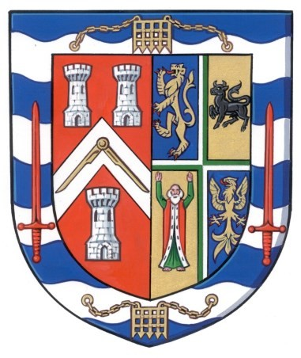

Toast List
The Queen and the Craft

* * *
The Most Worshipful The Grand Master His Royal Highness The Duke of Kent KG, GCMG, GCVO, ADC

* * *
The Most Worshipful Pro Grand Master Peter Geoffrey Lowndes The Right Worshipful Deputy Grand Master Jonathan Spence
The Right Worshipful Assistant Grand Master Sir David Hugh Wootton
and the rest of the Grand Officers, Present and Past

* * *
The Right Worshipful Metropolitan Grand Master Sir Michael Snyder

* * *
Holders of Metropolitan Ranks and Provincial and District Grand Officers, Present and Past

* * *
The Worshipful Master

* * *
The Installing Master

* * *
The Visitors

* * *
The Tyler’s Toast

